Albuquerque Bonsai Club

June 1, 2024 Meeting Notes

1. *Japanese Black Pine (JBP) Spring Decandling Demonstration – Skhye*

Japanese Black pines, native to coastal areas of Japan, are one of a few species of pines that are capable of two flushes of growth in a single season. Encouraging the second growth can result in accelerated ramification and maturation of your JBP.

Skhye brought one of his developing JBP’s and demonstrated the technique of removing the first flush candles (pine tree terminology for early growth buds) from his tree. The objective is for the tree to respond with a second flush of two (or more) buds at each cut site – accelerating the branch ramification by a factor of two!

Skhye also demonstrated the parallel technique of plucking needles from the stronger branches (usually, at the top) to balance the growth strength across the entire tree.

We are looking forward to a return demonstration in the fall where Skhye will select the two new buds for each branch (there could be three or more new buds at a cut site, but we only want to keep two) to complete the multi-flush JBP growth cycle.

*Japanese Black Pine Before Decandling*

1. ***Weather for June***

Expect HOT. And windy. June is often our warmest month with daily temperatures wandering into the 100’s. Add a high frequency of windy days to the mix and you have a challenging environment for our bonsai trees. Solution: be diligent about watering and misting your trees to keep them from getting dehydrated!

1. ***Mother’s Day Show (May 11 and 12) Review***

After several months of planning and preparation, the annual Albuquerque Bonsai Club’s annual Mother’s Day Bonsai Show at the Albuquerque BioPark Atrium took place on Mother’s Day weekend. And a very successful MDS Bonsai Show it was!

Club member volunteers adjusted to a new set up schedule (now, including Thursday) to get everything prepared by Friday afternoon for our guests (i.e., the public) to arrive on Saturday morning.

Our Mother’s Day bonsai display included forty-five bonsai trees, numerous assorted Kusamono and several Suiseki (viewing stones). A record for the MDS!

Saturday was a rough day from a weather perspective with rain and threatening rain depressing attendance. However, Sunday was a wonderful Mother’s Day with cool weather and bright sunshine! Total attendance for the two days, based on our People’s Choice Award ballots (Thank you Athena), was 954!

We closed the display at 4:00 pm to ensure all of our trees and people could go home by 5:00 pm. Our tear down volunteers came back on Monday morning to complete our tear down effort.

Well done Albuquerque Bonsai Club!

Photos attached!

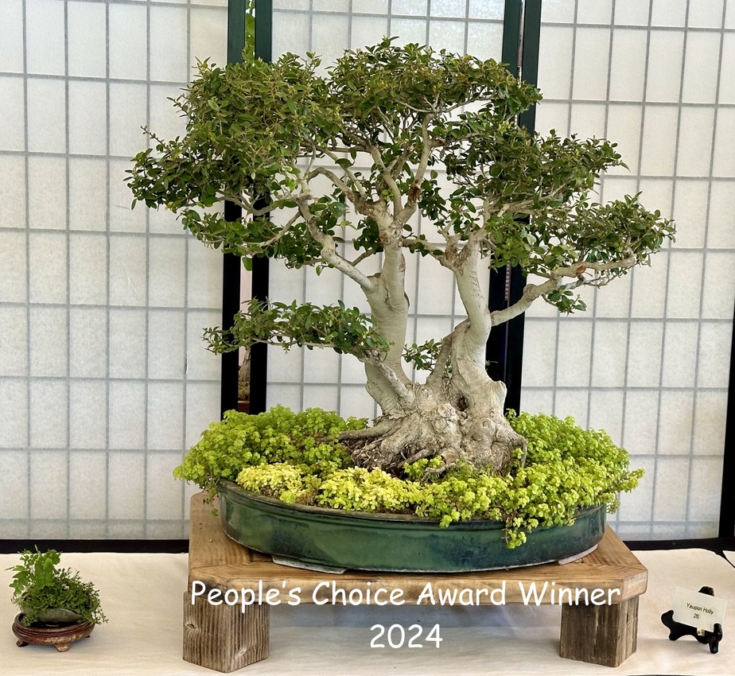

*2024 Mother’s Day Show People’s Choice Award Winner*

1. ***Upcoming Meeting and Events.***

Next meeting: Saturday, July 6 at the Heights Cumberland Presbyterian Church

Next workshop: Saturday July 20. Location TBD.